VIT UNIVERSITY

APPLICATIONS OF DIFFERENTIAL EQUATIONS

MAT2002

experiment-4

Faculty: Dr. Mellacheruvu Naga Srinivasu slot:L49+L50 venue:SJT319

**NAME: KARANI JASWANTH REG.NO:16BIT0058**

**DATE:08/02/2018**

**MATLAB CODE:**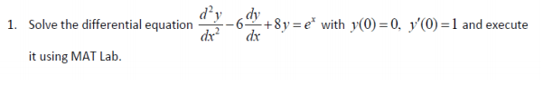

clc

clear all

close all

eqn=input('enter the equation');

inits=input('enter the conditions');

y=dsolve(eqn,inits,'t');

soln=['y(t)=',char(simplify(y))];

disp(soln)

ezplot(y)

**INPUT:**

enter the equation'D2y-6*Dy+8*y=exp(x)'

enter the conditions'y(0)=0,Dy(0)=1'

**OUTPUT:**

y(t)=((exp(2*t) - 1)*(4*exp(2*t) - exp(x) + exp(2*t)*exp(x)))/8

**GRAPH:**